**Case Study ML**

* By Thosic Tarun Bellana

Data Preparation:

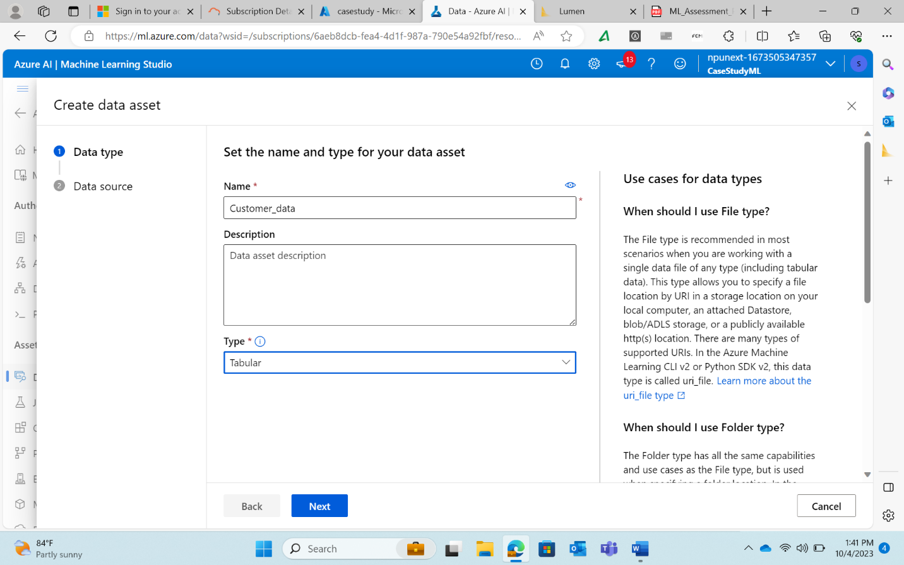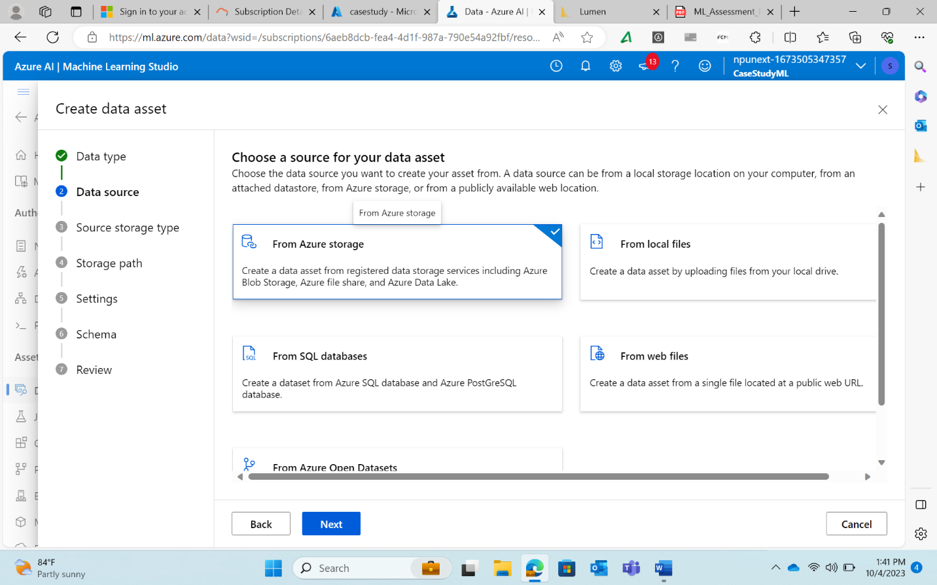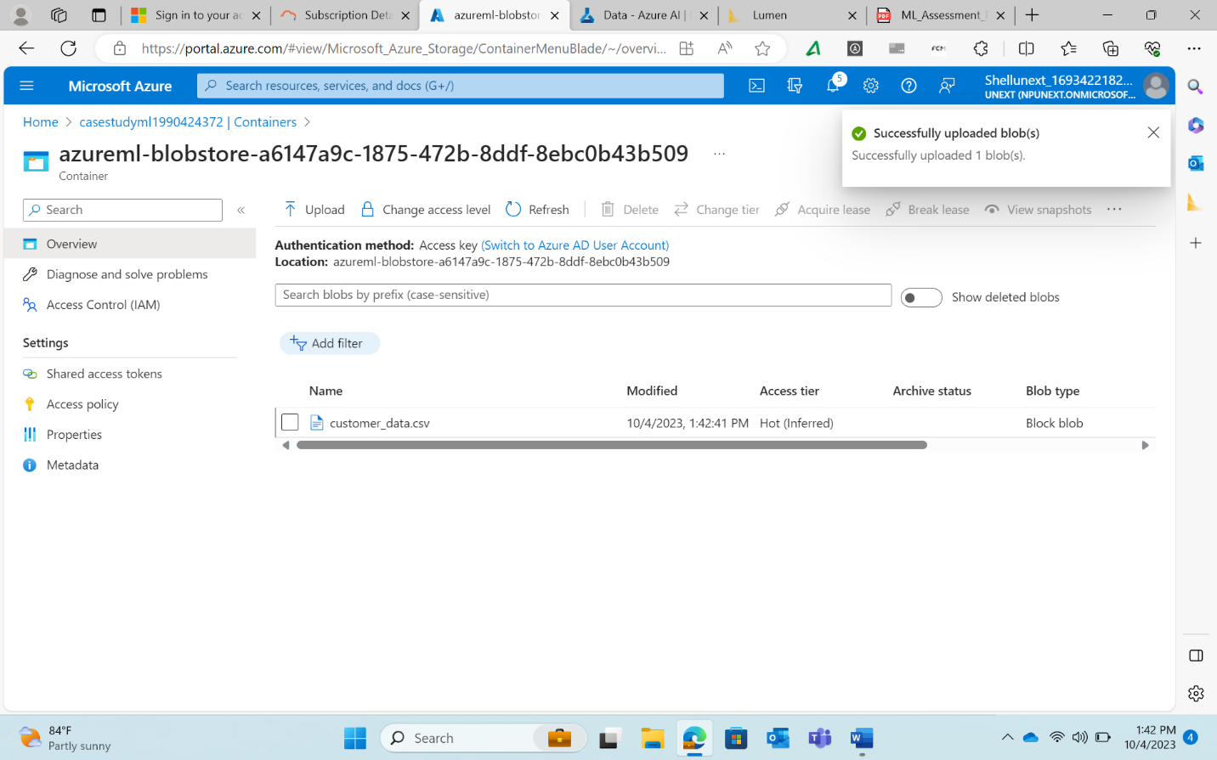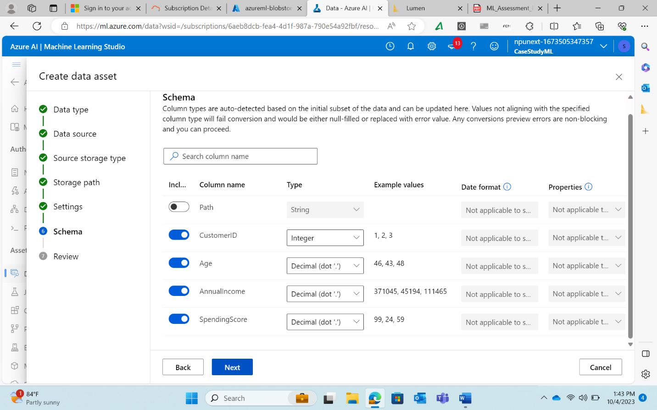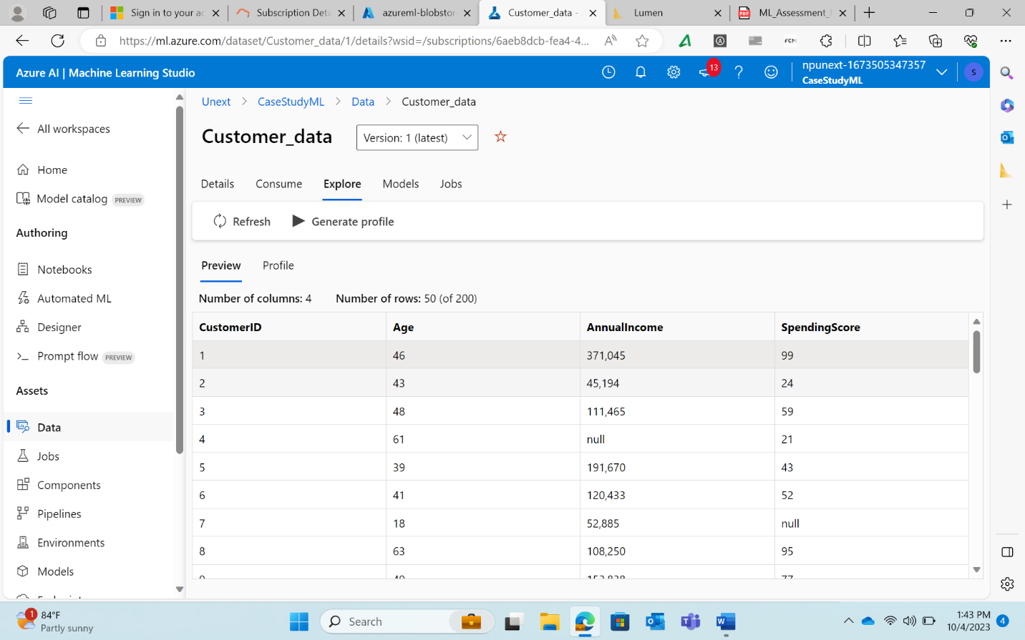

Model Development:

1. Choosing ML Algorithm(Linear Regression): A screenshot of a computer

   Description automatically generated
2. Splitting The dataset: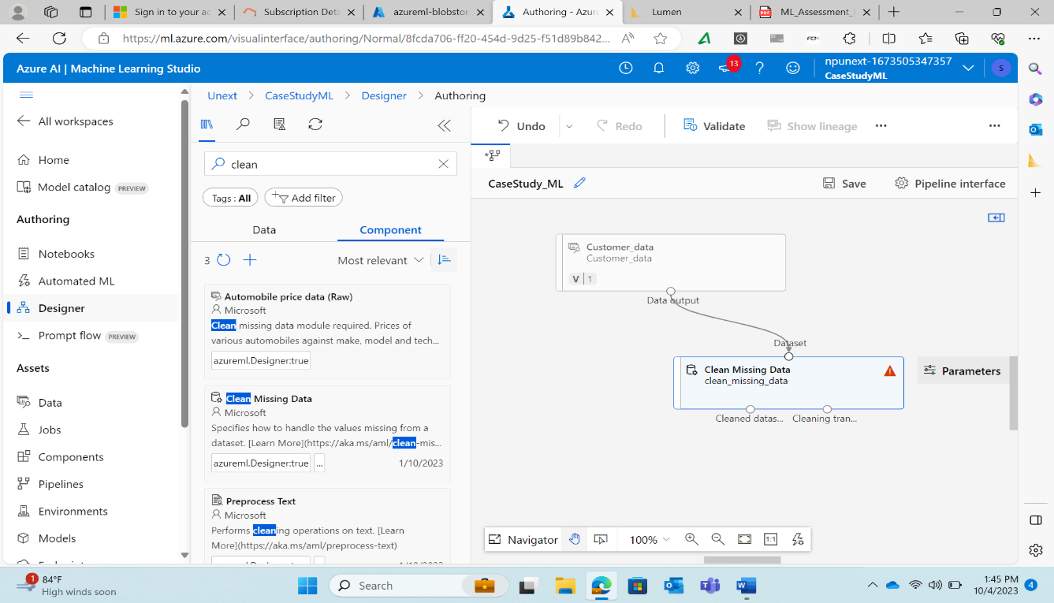

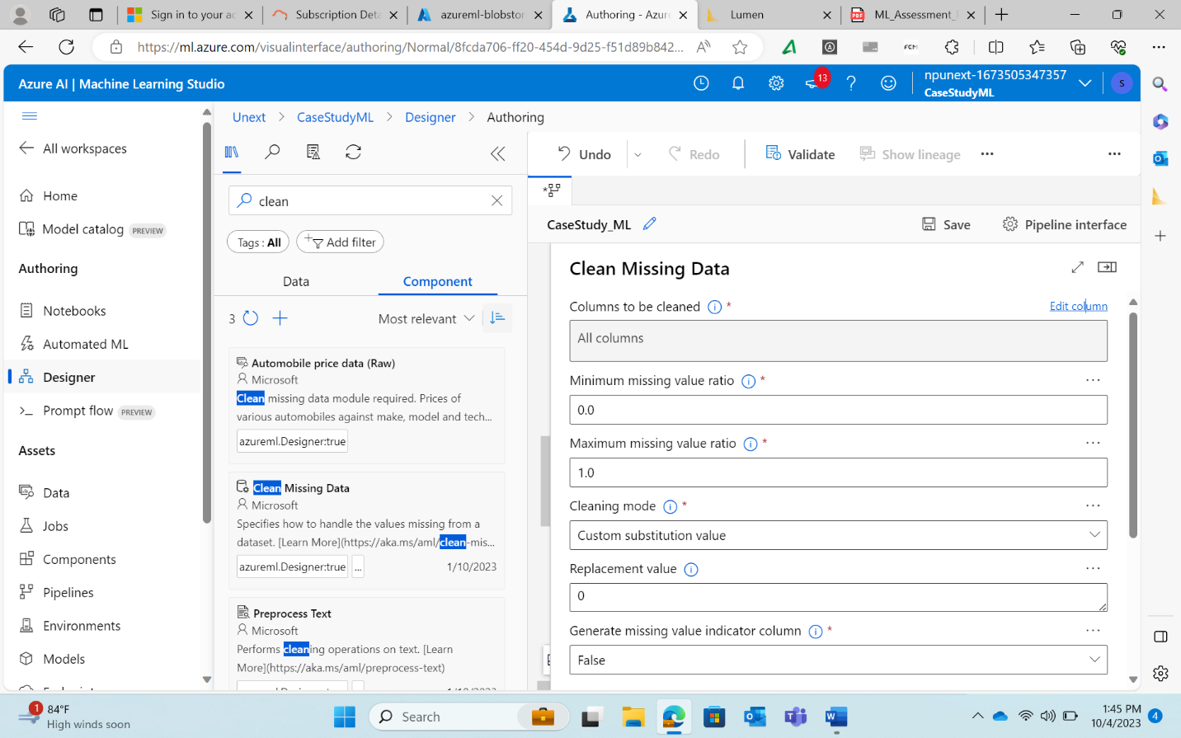

c) Training The model :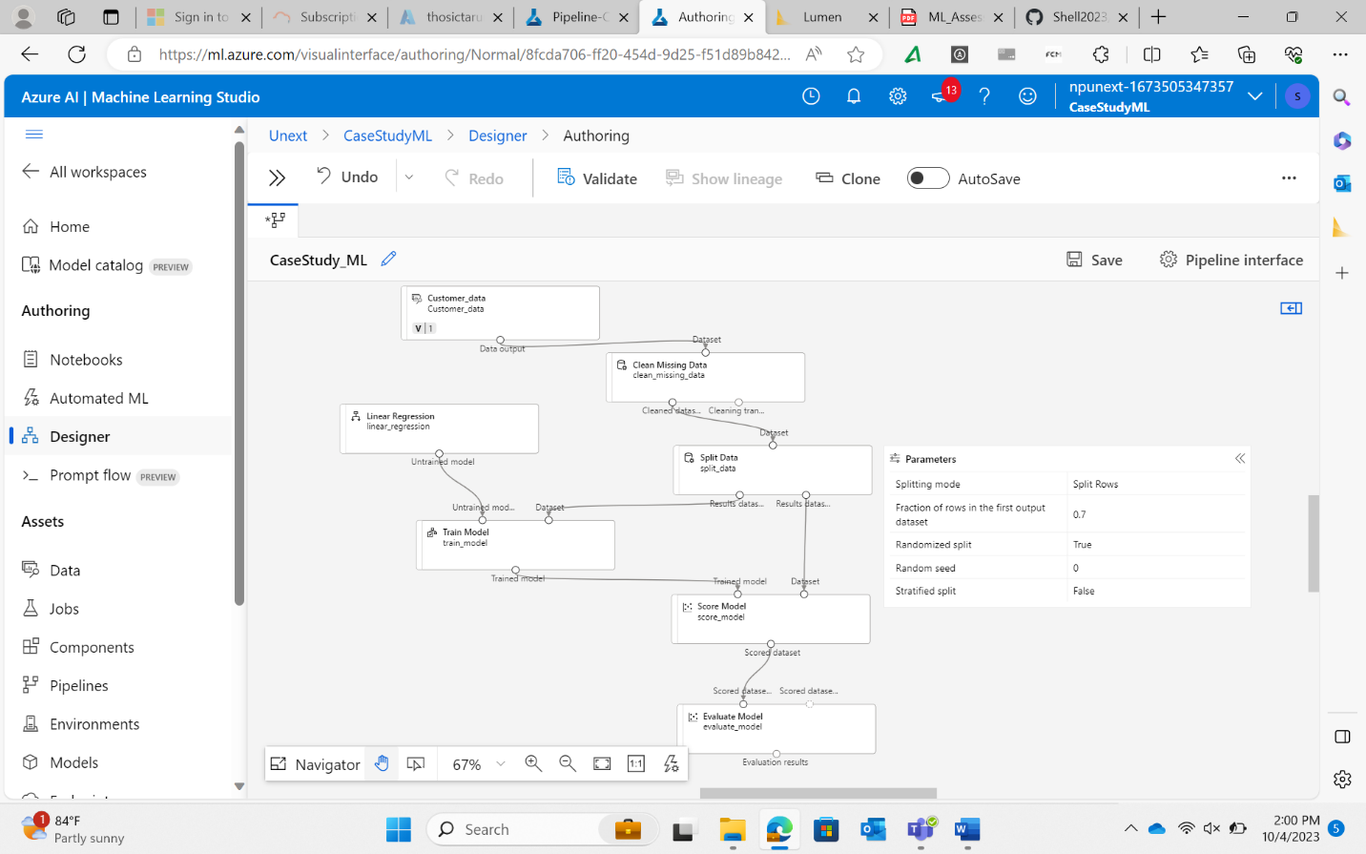

d)Evaluating Models Performance:

HyperParameter Tuning:

Answers for Assessment Questions:

1)Key steps involved in preparing the dataset for training are cleaning the dataset, by replacing null values, splitting the dataset into test and train data sets, and choosing the appropriate learning algorithm etc. and then score model and evaluate for evaluating the measures.

2) It is important to split the same dataset into test and train datasets

3) I choose Linear Regression for predicting the customer’s purchasing behaviour.

4)Hyperparameter tuning is used while training for the optimized predictions , where the errors are minimal compared to train data component.